Exe 1 and 2

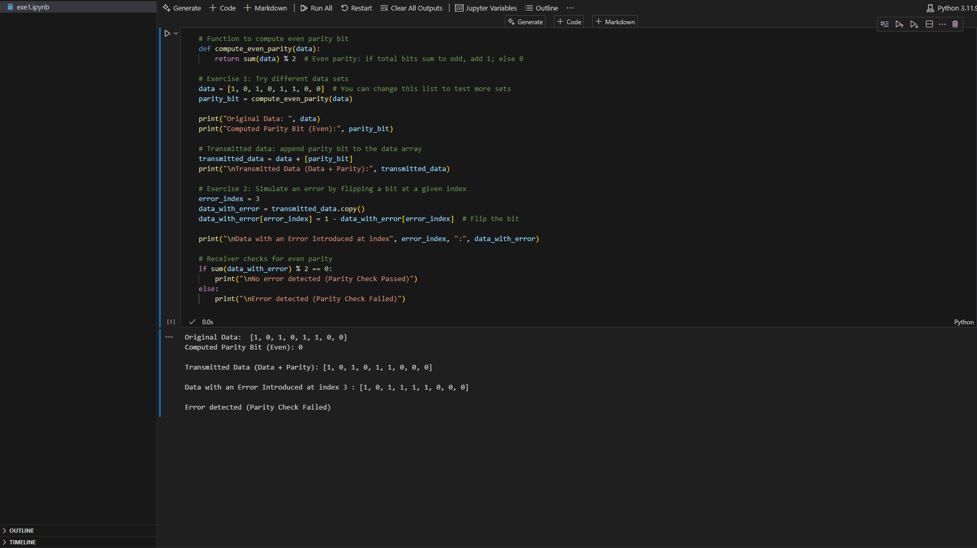

Exe 3

  
  
